MY SQL “CARDINAL INVENTORY SYSTEM ERD” CREATION QUERY  
  
  
tb_users  
  
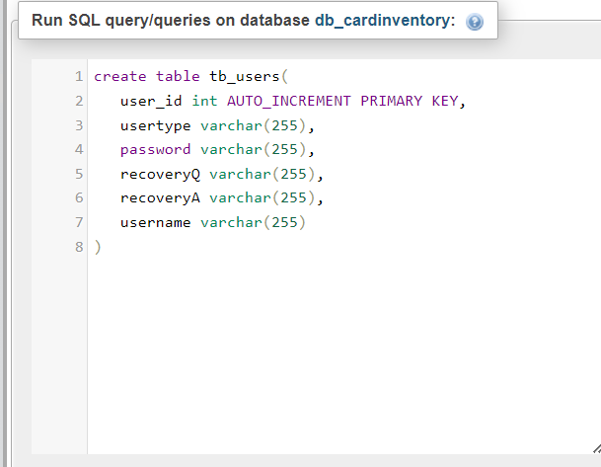

Tb_loginhistory  
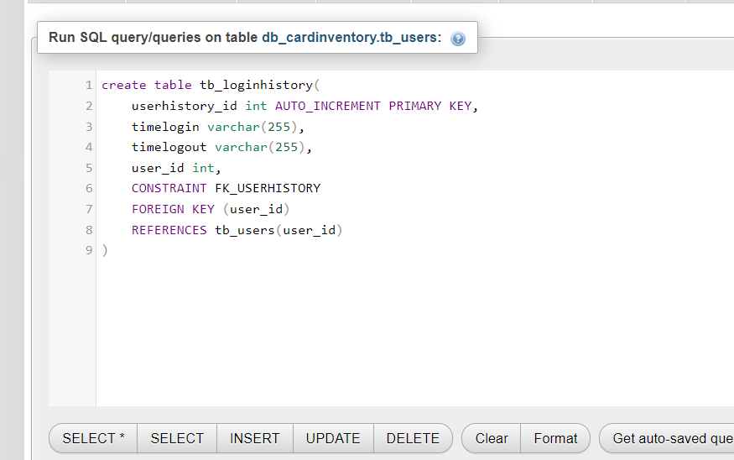

Tb_productinfo  
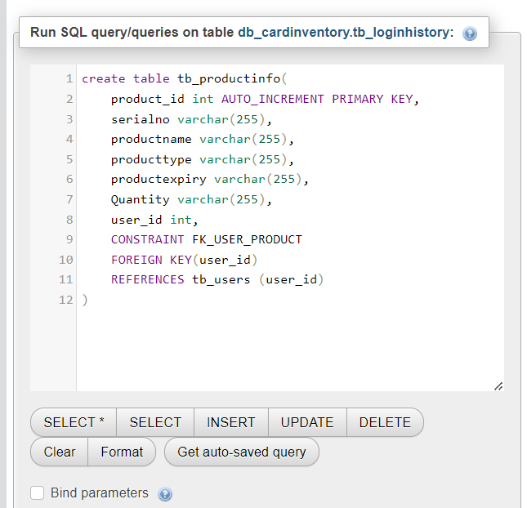

tb_pendproduct  
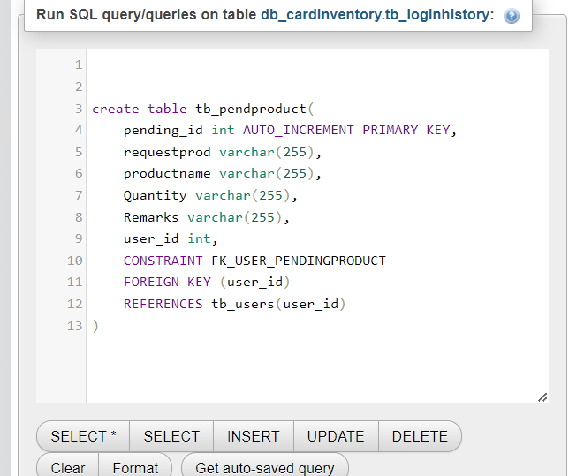  
  
tb_deliverytab  
